Developing the Visual Midwifery Mobile Application

Jared Steele
Project Manager of Otago meddIT
Forth Street, Dunedin 9016
Otago, New Zealand
0064 03 477 3014
Steeljm1@student.op.ac.nz
Samuel Glenn
Software Engineer of Otago meddIT
Forth Street, Dunedin 9016
Otago, New Zealand
0064 03 477 3014
Glennsp3@student.op.ac.nz
Bo Liu
Software Engineer of Otago meddIT
Forth Street, Dunedin 9016
Otago, New Zealand
0064 03 477 3014
Liub3@student.op.ac.nz

ABSTRACT
In this paper, we describe the processes involved in the development of the interactive mobile learning application Visual Midwifery.

INTRODUCTION

With the growth of the internet and mobile telecommunications technology worldwide, this has made it possible for educational institutions to offer the opportunity for students who live in remote areas to access learning material. In April 2000 a survey conducted by the U.S Department of Education’s National Centre for Educational Statistics revealed that the number of distance education programs increased by 72% from 1994 to 1998 with an additional 20% of institutions planning to establish distance education programs within the following three years (The Institution for Higher Education, April 2000). Research revealed that the majority of leading tertiary institutions in New Zealand have distance education programs. The midwifery school that we are developing the application for is made up largely of distance learning students. International Confederation of Midwives standards guidelines state that midwifery curricula include both theory and practice elements with a minimum of 40% theory and a minimum of 50% practice (ICM, 2010). According to a study conducted by the Birmingham City University there has been a growing number of first year nursing and midwifery students failing theory assessments (Hunt, L.A., et al, 2010). The application we are developing is an attempt to address the issue of raising distance learning student’s theoretical knowledge while maintaining an active life style.

Problem Statement

In this literature review, we will address the following question: How can we design a mobile application that will successfully engage student midwives in their learning.
.

Literature Review

Engage Learning

As the application we are creating is a learning tool for midwifery students, we must establish a means of engaging these students with the application. Over the past decade educational institutions have been a putting a large emphasis on the concept of student engagement. In order to engage students with their learning we must also understand what engagement is? Webster’s collegiate dictionary (1979) defines engagement as: a) the act of engaging: b) to hold the attention of. How does engagement apply to students and the term ‘student engagement’? Trowler (2010) states that based on definitions in literature the term ‘student engagement’ can be summarized as:

Student engagement is concerned with the interaction between the time, effort and other relevant resources invested by both students and their institutions intended to optimize the student experience and enhance the learning outcomes and development of students and the performance, and reputation of the institution.

Student engagement has also be defined as “the extent to which students are engaging in activities that higher education research has shown to be linked with high-quality learning outcomes” (Krause & Coates, 2008, 493). The mission of any educational institution is to engage students by providing the conditions and environment in which learning will blossom. This poses the question: how do instructors get their students to engage with their learning if the students are distance learners? Instructors need to be innovative and creative in the design and implementation of curricula to address this question. Before the introduction of the internet much of the distance learning material was accessed via a text book. The internet changed the way of the world, pushing mankind into what is known as the information age. The internet also gave way to an evolutionary concept of learning called e-learning which allowed instructors to deliver a blended (b-learning) style model of curricula incorporating face to face contact, static, dynamic and interactive material.

The b-learning model has been the answer to the question of addressing distance learning by educational institutions since the mid-nineties. This blended approach to learning brings together pedagogy and technology, learning activities, and assessment criteria. In terms of distance learning education, educators have been forced to combine pedagogically teaching and design with technology in order to attempt to engage distance students with their learning; however, Krause (2006) suggests “Given the heterogeneity of any student body, it is quite likely that ‘engagement’ will mean different things to different students. It has to be unlikely that within an increasingly heterogeneous student population, there is one measure or one definition of ‘engagement’ that encapsulates the level of motivation or the learning goals of each individual student.”

We believe Krause makes a valid point, as no two students engage with learning in the same way. Educators need to recognize that students learning styles differ in the way information is grasped and processed. It is equally important for educators to understand learning is a process as opposed to a product. Kolb (1984) claims that the process of learning consists of four stages: 1) concrete experience, 2) reflective observation, 3) abstract conceptualization, and 4) active experimentation. Solvie & Kloek (2007) ask the question: “Would technology-enhanced learning experiences aligned to learning styles of students support a constructivist setting and students’ understanding of course content?” Brill & Park (2008) also ask a similar question: “What technologies are emerging as potentially useful learning technologies?”

E-learning introduced a wide range of technologies that we believe address Kolb’s process of learning theory: Smart (electronic) boards, audio and video clips to engage students in experiments to provide students with concrete experience to support the construction of knowledge. The use of wikis, blogs, and forums encourage reflective thinking. Abstract conceptualization has been addressed by the use of web pages, word documents, pdf’s, and content available via external sites. Prompting students to demonstrate their skills and knowledge, and speaking about their work may address the process of active experimentation (Cope & Kalantzis, 2000).

To summarize briefly, “digital networks have evolved from carrying data in a transactional sense to facilitating social interactivity and that the society is extending from the information age into an interaction age (Milne, 2007, p.14).”

Mobile Learning
In recent years mobile technology has advanced at a rapid rate. As we know, a mobile phone is no longer just a device that we can make phone calls from or send instant messages to others. Mobile devices are more powerful and portable nowadays offering a variety of tools to assist users handle tasks in their daily life. With the introduction of new mobile technology, there has been a shift in ideas of how make use technology this to deliver educational material to students.
Wellman (2007) states that mobile devices are rapidly becoming the key to making information “universally accessible”; however, in light of the information age evolving into what is becoming an interactive age, Trowler (2010) argues that these technologies must contribute to student learning, and in particular, student engagement in learning.

Evolution of learning/teaching methods…..

In order to realize its potential, effective methods for offering high-quality and accessible m-learning are required.
M-learning has been championed as “a personal, unobtrusive, spontaneous, ‘anytime, anywhere’ way to learn and to access educational tools and material that enlarges access to education for all” (Kukulska-Hulme & Traxler, 2005, p.1).
Traxler (2009) suggests: Mobile learning exploits both handheld computers and mobile telephones and other devices that draw on the same set of functionalities. Mobile learning using handheld computers is obviously relatively immature in terms of both its technologies and its pedagogies, but is developing rapidly. It draws on the theory and practice of pedagogies used in technology enhanced learning and others used in the classroom and the community.

PLATFORM/TECHNOLOGY JUSTIFICATION

Platform

Support System
When the time came for us to decide what operating system we were going to use as the back end system, we recognized that the system would need to have the ability to run applications and services required of the framework efficiently. The framework requires the functionality of an Apache, MySQL, and PHP solution stack (software suite). Apache, MySQL, and PHP have been ported to most of the operating systems currently in use by the industry. They are all open source enterprise-level web applications and are maintained by an active worldwide community of developers. The use of these applications has allowed us the freedom to customise the applications to suit the needs of the framework.
Critical factors we identified when choosing the operating system that would support the web applications are stability, reliability, security, and cost. These factors lead us to look at virtualization technology. With the rise in popularity of virtualization and cloud technology many large companies and organizations are consolidating their servers and moving toward a virtual infrastructure. Many tertiary educational institutions are also adopting this technology. The answer to the question of why consolidate servers via virtualization is simple, reduce IT costs and increase control. Server consolidation has significant advantages to organizations. A few of these advantages include:
- Reduced hardware and operating costs
- Reduced time in provisioning new servers
- Decreased downtime
- Improved server reliability and disaster recovery
Otago Polytechnic in Dunedin, New Zealand has embraced virtualization technology and offers the use of this technology to students in the B.InfoTech program. Furthermore, much of the institution’s IT infrastructure is virtualized and also delivers virtual desktops to its students so they can work remotely.
We chose to build the solution stack on the Debian GNU/Linux 7.0 (codename “wheezy”) distribution. Debian is an open source operating system composed of free software packages and has a long history of being stable, reliable, and secure. Every package contained in Debian is maintained by a single individual or group of individuals known as maintainers. It is their responsibility to ensure that the packages are well documented, kept up-to-date and free of bugs (Debian Installer Team [Debian], n.d.). Debian has a large user base and combined with a bug tracking system ensures that bugs found in packages are fixed quickly and updates can be supplied to users in a timely fashion.
Debian’s default package manger apt made the installation of the required web applications very easy. Apt does an excellent job identifying application dependencies such as development libraries and so on.

Moodle
For many years Otago Polytechnic had been using Blackboard as a Learning Management System (LMS). In 2004 Otago Polytechnic IT Support (ITS) staff along with the B.InfoTech trialed Moodle (LMS) as an alternative system. The institution eventually made the decision after a few years to migrate to Moodle and the system has now been using Moodle since 2010.
One of the primary functional requirements of the system is to allow user the ability to take short quizzes on course curriculum contained within mobile app. In 2013 we created the first prototyped version of Visual Midwifery as a project in the six month second year B.InfoTech paper Software Engineering. We created a quiz function in that version; however, the quiz was hard-coded into the app and as a result of that the lecturer of the course was not able to edit the quiz if required.
As students in the B.InfoTech program at Otago Polytechnic, we started using Moodle in the first year of our degree. We learnt that Moodle has a quiz module built in to the system and that the quiz module is used by many of the other programs with the school. Moodle is a free open source LMS which enables educators to create their own private website filled with dynamic courses that extend learning, anywhere, any time (Moodle.org, 2014). Moodle’s core is extremely customizable and comes packaged with an array of activity modules. We were particularly interested in the quiz module. We decided to use the Moodle’s quiz module in the application for three main reasons:
- Students are already familiar and comfortable using Moodle
- Support from the developer would not be required if the lecturer wanted to make changes to any of the quizzes within the application
- Lecturers have the freedom to edit and create quiz questions when needed
Given that Moodle is an open source application and also has a large community of developers, Moodle has a range of custom themes.
As the application will be used primarily by users via mobile devices it was necessary to fashion the user interface to be viewed on such devices. The release of Moodle 2.5 in May 2013 saw the introduction of a new bootstrap theme called Clean. The theme allows developers to modify the HTML and CSS in such a way that the webpages will be displayed correctly on smart phones and tablets. We installed the theme and made modifications to the code to suit our particular requirements. The changes to the code produced the result that we were looking for which was responsive web view.

Active directory….
Many large organizations use some kind of authentication system which allows users and computers to connect to a network domain. The most popular system used in industry today is Microsoft Active Directory. Active Directory is a means of authenticating users and computers in a Microsoft Windows domain type network. Since Otago Polytechnic uses Active Directory to authenticate users on their network, we felt it was an obvious choice to incorporate this technology into our system. This would allow students to access Moodle quizzes via the mobile app using their school logins. Coincidentally Moodle is packaged with a Lightweight Directory Access Protocol (LDAP) authentication plugin which can be configured to connect the Moodle instance to an existing Active Directory domain.

Unfortunately, we were unable to gain permission from Otago Polytechnic’s IT Support (ITS) staff to connect our system to the polytechnic infrastructure. To gain experience and to test the LDAP plugin in Moodle, we installed Microsoft Server 2012 R2 on a virtual machine and setup Active Directory. We successfully created an Active Directory environment (figure x.) almost identical to Otago Polytechnic and were able to authenticate domain users on Moodle.
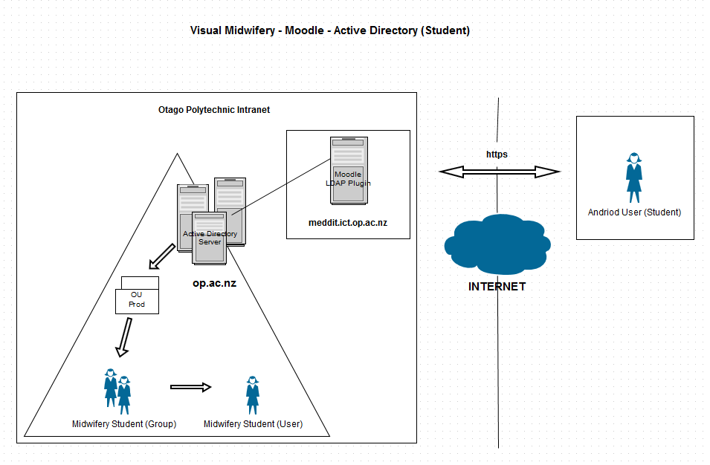
Figure X. Moodle LDAP

SilverStripe
The SilverStripe content management system is used as a platform to host content to be requested by the android application. The CMS stores information in a structure recognizable to the android application so it may unpack the data and form models. Using the SSCMS (SilverStripe Content Management System), a lecturer will be able to upload information wanting to be displayed by the android application.

Server Automation
One of the main goals of the framework is ability to create new systems based on a generic system but tailored to meet the requirements of the client’s desired application. During early stages of the framework development process we recognized that it would be advantageous and later become necessary to use server automation software in order to make this process possible. Server automation would allow us to create configuration templates (manifests/modules) of application and the desired server state. The software would also be required to manage configuration files, libraries, and services on the system.
Server automation software would benefit the development team, client, and the end user by allowing for rapid deployment times via continuous delivery, reduced down time of core services, and reduced IT support costs.

We decided to use the open source version of Puppet by Puppet Labs. Puppet is available as a binary package for Debian which makes installation effortless with the apt package manager. Puppet uses a declarative language for expressing server configuration.

DEVELOPMENT PROCESS

Mobile Application

Support System

ARTEFACT DESCRIPTION

Interaction Design
We identified the following user tasks:

User Interface

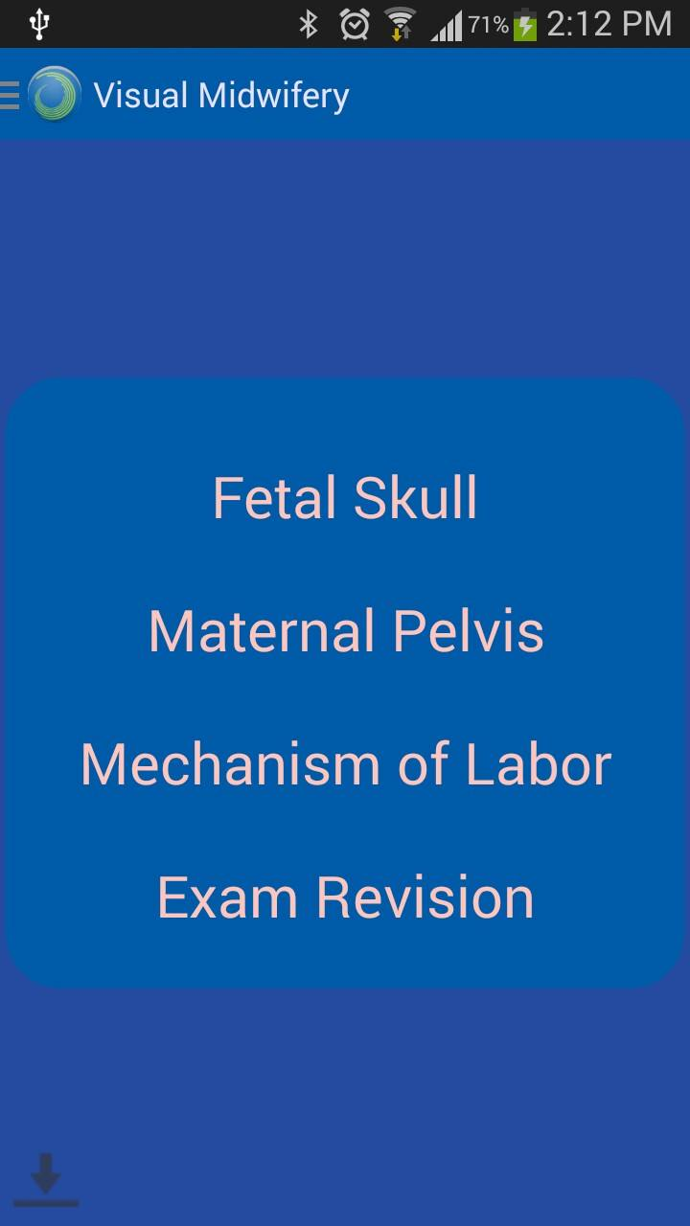
Figure X. Screenshot of main menu

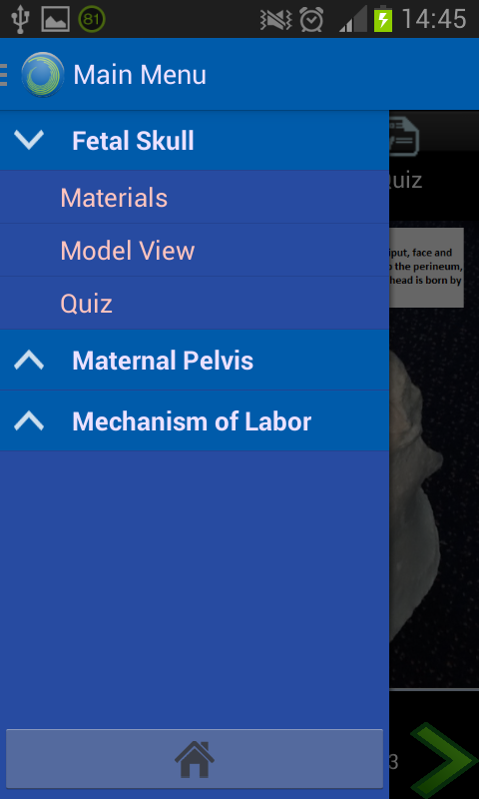
Figure X. Navigation drawer
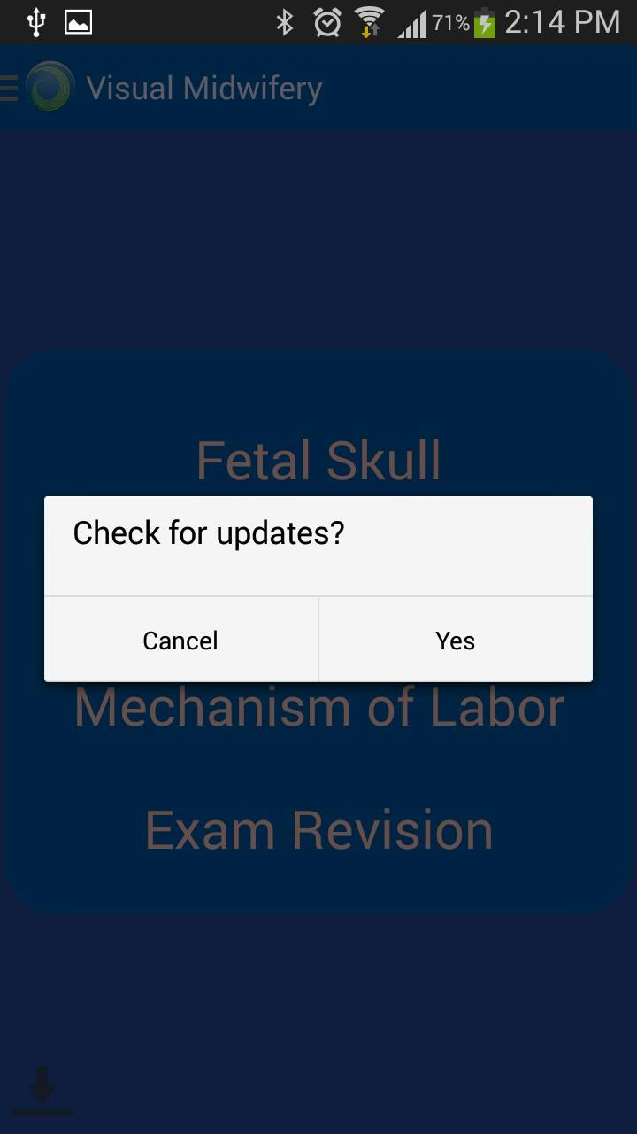
Figure X. Screenshot of content update dialog

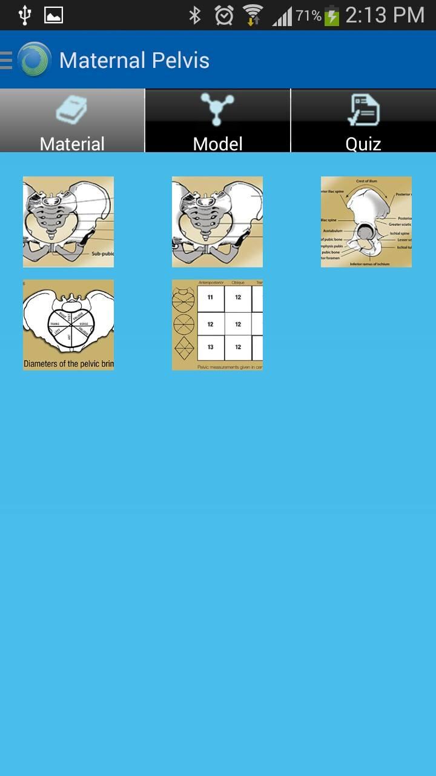
Figure X. Screenshot of content slides


Figure X. Screenshot of Fetal Skull model

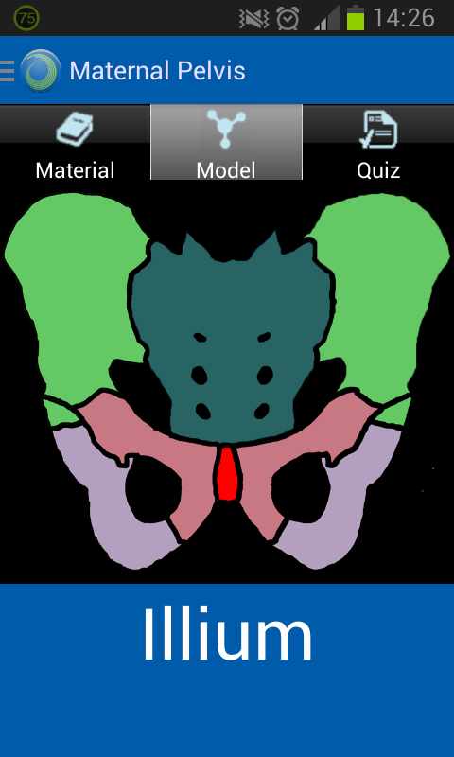
Figure X. Screenshot of Maternal Pelvis model

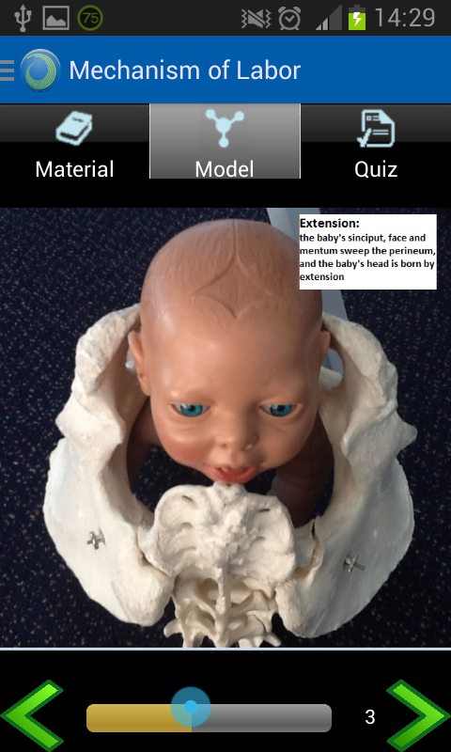
Figure X. Screenshot of Mechanism of Labor sequence

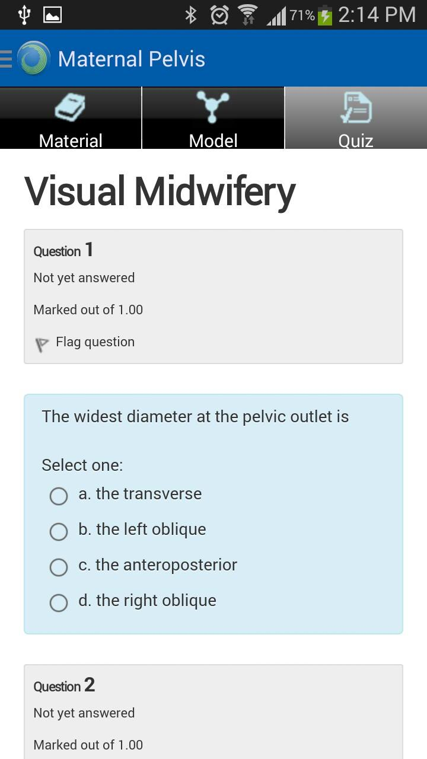
Figure X. Screenshot of Moodle quiz
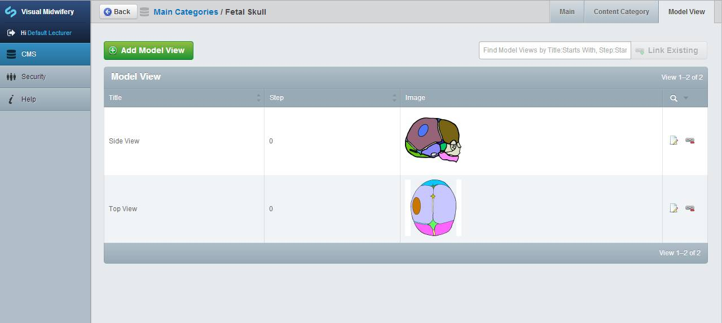Figure X. Content Management System

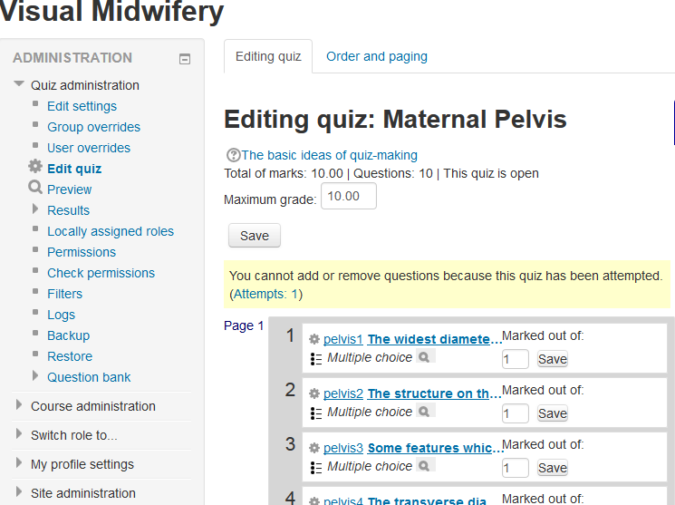Figure X. Moodle quiz administration

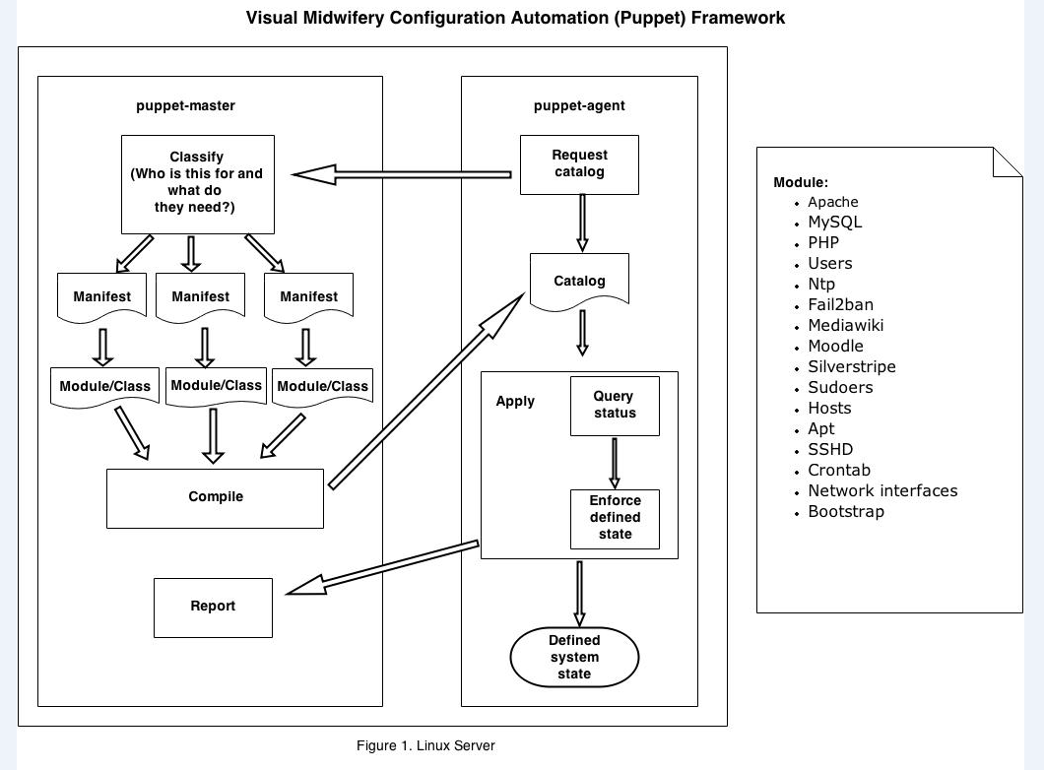Figure X. Server configuration via Puppet

Mapping of Functional Requirements to Completed System

Table 1. Functional Requirements
FR Number | Requirement | Completed System
FR1 | View static images | Complete (Figure X)
FR2 | Interact with image models | Complete (Figure X)
FR3 | Modify app content via CMS | Complete (Figure X)
FR4 | Take quiz | Complete (Figure X)
FR5 | Synchronize mobile and CMS databases | Complete (Figure X)
FR6 | Navigation drawer | Complete (Figure X)
FR7 | Server automation/Continuous delivery | Complete (Figure X)

Technical Highlights

Part One

Part Two

Part Three

Part Four

TESTING

DEVELOPMENT EVIDENCE

ANALYSIS & FUTURE WORK

CONCLUSION

ACKNOLEDGMENTS

REFERENCES
- Anderson, T., & Dron, J. (2011). Education Pedagogy. International Review of Research in Open and Distance Learning, 12(3), 80-97. CIDER sessions;. Retrieved from http://www.irrodl.org/index.php/irrodl/article/view/890
- Caudill, J. G. (2007). The Growth of m-Learning and the Growth of Mobile Computing: Parallel developments. International Review of Research in Open and Distance Learning, 8(2), 1-13. Retrieved from http://www.irrodl.org/index.php/irrodl/article/view/348
- Cope, B., & Kalantzis, M. (Eds.). (2000). Multiliteracies: Literacy learning and the design of social futures. New York: Routledge.
- Dabbagh, N., & Kitsantas, A. (2004). Supporting Self-Regulation in Student-Centered Web-Based Learning Environments. International Journal on E-Learning, 3(1), 40-47.
- Diemer, T. T., Fernandez, E., & Streepey, J. W. (2012). Student Perceptions of Classroom Engagement and Learning using iPads. Journal of Teaching and Learning with Technology, 1(2), 13-25.
- Hunt, L.A., et al. (2010). Assessment of student nurses in practice: A comparison of theoretical and practical assessment results in England, Nurse Educ. Today, doi: 10.1016/j.nedt.2011.05.010.
- Kearney, M., Schuck, S., Burden, K., & Aubusson, P. (2012). Viewing mobile learning from a pedagogical perspective. Research in Learning Technology.
- Kolb, D. (1984). Experiential learning: Experience as the source of learning and development. Englewood Cliffs, NJ: Prentice-Hall, Inc.
- Krause, K. & Coates, H. (2008) Student’s Engagement in First-Year University. Assessment and Evaluation in Higher Education. 33 (5), pp. 493-505.
- Martin, S., Gil, R., Diaz, G., Sancristobal, E., Castro, M., & Peire, J. (2008). From e-learning to m-learning through b-learning and s-learning. 2008 50th International Symposium ELMAR.
- Solvie, P., & Kloek, M. (2007). Using technology tools to engage students with multiple learning styles in a constuctivist learning environment. Contemporary Issues in Technology & Teacher Education, 7(2), 7-27. Retrieved from http://search.ebscohost.com/login.aspx?direct=true&db=psyh&AN=2007-15160-001&loginpage=Login.asp&site=ehost-live&scope=site.
- Stefani, L. (2008). Engaging our Students in the Learning Process: Points for Consideration. International Journal for the Scholarship of Teaching and Learning. Retrieved from http://academics.georgiasouthern.edu/ijsotl/v2n1/invited_essays/Stefani/Invited_Essay_Stefani.
- Trowler, P. (1998) Academics Responding to Change: New Higher Education Frameworks and Academic Cultures. Buckingham: Open University Press/ SRHE.

